**How Can Small Businesses Manage GST Return Filing More Effectively?**

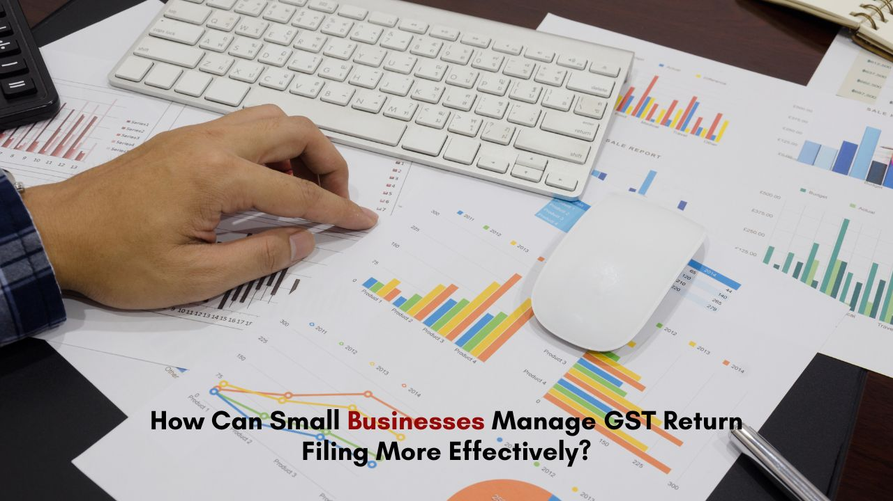

## **Introduction**

For small businesses in India, managing tax compliance can be a challenging task, especially when it comes to filing GST returns. With a clear understanding of GST registration and its requirements, businesses can streamline their processes, avoid penalties, and ensure smooth operations. This blog explores practical tips for small businesses to manage GST return filing effectively while addressing related aspects such as TDS return filing, income tax return filing, and salary return filing.

**Understanding GST Registration and Its Importance**

GST registration is the first step for any business to comply with India’s Goods and Services Tax regulations. It allows businesses to collect GST from customers and claim input tax credit. Without proper registration, businesses not only risk penalties but also lose credibility with clients and suppliers.

Small businesses should ensure they meet the threshold turnover for GST registration and provide the necessary documentation. The documents required for [**GST registration**](https://corpbiz.io/gst-registration)include PAN of the business or owner, proof of business address, bank account details, and business incorporation certificates. Keeping these documents updated and accessible can simplify the process and prevent last-minute hurdles.

Managing GST return filing for small businesses can become daunting due to several factors such as limited resources, lack of technical know-how, and frequent policy updates. Many small enterprises struggle with reconciling invoices, maintaining proper records, and adhering to deadlines.

Moreover, small businesses often face challenges when filing TDS returns and salary returns, adding to the complexity of managing overall tax compliance.

**Tips for Streamlining GST Return Filing**

To make GST return filing less cumbersome, small businesses can adopt the following strategies:

* **Use Technology to Automate Tax Processes**

Several online platforms provide tools to simplify [**GST return filing for small businesses**](https://corpbiz.io/gst-return-filing). These tools help automate tasks such as invoice generation, tax calculation, and return preparation. By using these solutions, businesses can reduce manual errors and save valuable time.

* **Maintain Accurate Records:**

Keeping detailed and accurate records of all financial transactions is critical. Small businesses should ensure invoices are GST-compliant and regularly reconciled. Proper documentation also aids in smooth input tax credit claims and reduces discrepancies during audits.

* **Leverage Professional Assistance**

For businesses lacking in-house expertise, hiring professionals for GST return filing, TDS return filing, or income tax return filing can be a game-changer. Chartered accountants or tax consultants can provide valuable insights, ensure compliance, and minimize risks.

**TDS Return Filing and Its Role in Tax Compliance**

TDS return filing is another critical aspect of tax compliance for small businesses. It involves reporting the tax deducted at source on payments such as salaries, rent, or contractor fees. Timely and accurate TDS return filing helps avoid penalties and ensures the business remains on good terms with tax authorities.

[**Online TDS return filing**](https://corpbiz.io/tds-return-filing) platforms simplify this process by providing user-friendly interfaces and reducing paperwork. Small businesses should ensure TDS is deducted correctly and deposited within the stipulated timelines to maintain compliance.

Many businesses overlook the importance of integrating GST and TDS compliance to ensure seamless operations. Misalignment between these two processes can lead to financial discrepancies and increased scrutiny. Using comprehensive tax management software can help businesses streamline both GST and TDS return filing effectively.

**Income Tax Return Filing for Small Businesses**

Income tax return filing is another responsibility that small businesses must address diligently. Properly filing income tax returns not only ensures compliance but also builds credibility and improves access to loans or investments.

To simplify income tax return filing, small businesses should:

* Categorize income and expenses correctly.
* Keep track of deductions and exemptions applicable under the Income Tax Act.
* Use online filing platforms that guide users through the process step by step.

**Salary Return Filing for Small Businesses**

Salary returns filing involves reporting the taxes deducted from employees’ salaries to the tax authorities. Small businesses must ensure accurate calculations and timely deposits to avoid complications.

To streamline salary return filing, businesses can use payroll management software that automates tax calculations, generates Form 16, and prepares the necessary documentation for filing. Properly managing salary return filing contributes to employee satisfaction and boosts compliance.

**Importance of Staying Updated with Tax Laws**

Tax laws in India frequently change, and staying updated is essential for compliance. Small businesses should regularly monitor government notifications, attend workshops, or seek advice from tax consultants to understand new developments. Subscribing to newsletters from reliable sources or joining business forums can also help small businesses remain informed and adapt their processes accordingly.

For many small businesses, outsourcing tax compliance tasks such as GST return filing, TDS return filing, and income tax return filing can prove to be cost-effective. Outsourcing not only ensures accuracy but also allows business owners to focus on core operations without worrying about tax deadlines.

Partnering with a trusted tax consultant or service provider can help businesses manage documentation, stay compliant, and reduce the risk of penalties.

**Conclusion**

Managing GST return filing effectively is crucial for small businesses to thrive in a competitive market. By leveraging technology, maintaining accurate records, and seeking professional assistance when needed, small businesses can streamline their tax processes and ensure compliance with minimal stress. Additionally, paying attention to related aspects such as TDS return filing, [**income tax return filing**](https://corpbiz.io/income-tax-return-filing), and salary return filing further strengthens a business’s financial standing.

Adopting a proactive approach to tax compliance not only helps small businesses save time and money but also fosters trust among stakeholders, paving the way for sustainable growth.

Connect with **Corpbiz Legal Advisors** [www.corpbiz.io](https://www.corpbiz.io/) or at +91-9121230280.